**Maven Project – Library Management**

**Exercise 1: Configuring a Basic Spring Application**

**CODE:**

**Pom.xml**

<project xmlns="http://maven.apache.org/POM/4.0.0" xmlns:xsi="http://www.w3.org/2001/XMLSchema-instance"  
 xsi:schemaLocation="http://maven.apache.org/POM/4.0.0 http://maven.apache.org/xsd/maven-4.0.0.xsd">  
 <modelVersion>4.0.0</modelVersion>  
  
 <groupId>com.library</groupId>  
 <artifactId>LibraryManagement</artifactId>  
 <version>1.0-SNAPSHOT</version>  
 <packaging>jar</packaging>  
  
 <name>LibraryManagement</name>  
 <url>http://maven.apache.org</url>  
  
 <properties>  
 <project.build.sourceEncoding>UTF-8</project.build.sourceEncoding>  
 </properties>  
  
 <dependencies>  
 <dependency>  
 <groupId>org.springframework</groupId>  
 <artifactId>spring-context</artifactId>  
 <version>5.3.32</version>  
 </dependency>  
 </dependencies>  
  
</project>

**BookRepository.java**

package com.library.repository;  
  
public class BookRepository {  
 public void saveBook(String title) {  
 System.*out*.println("Saving book: " + title);  
 }  
}

**BookService.java**

package com.library.service;  
  
import com.library.repository.BookRepository;  
  
public class BookService {  
 private BookRepository bookRepository;  
 public void setBookRepository(BookRepository bookRepository) {  
 this.bookRepository = bookRepository;  
 }  
  
 public void addBook(String title) {  
 System.*out*.println("Adding book: " + title);  
 bookRepository.saveBook(title);  
 }  
}

**LibraryApp.java**

package com.library;

import com.library.service.BookService;  
import org.springframework.context.ApplicationContext;  
import org.springframework.context.support.ClassPathXmlApplicationContext;  
  
public class LibraryApp {  
 public static void main(String[] args) {  
 ApplicationContext context = new ClassPathXmlApplicationContext("applicationContext.xml");  
  
 BookService bookService = (BookService) context.getBean("bookService");  
 bookService.addBook("The Great Gatsby");  
  
 ((ClassPathXmlApplicationContext) context).close();  
 }  
}

**applicationContext.xml**

<?xml version="1.0" encoding="UTF-8"?>  
<beans xmlns="http://www.springframework.org/schema/beans"  
 xmlns:xsi="http://www.w3.org/2001/XMLSchema-instance"  
 xsi:schemaLocation="http://www.springframework.org/schema/beans  
 https://www.springframework.org/schema/beans/spring-beans.xsd">  
  
 <bean id="bookRepository" class="com.library.repository.BookRepository" />  
 <bean id="bookService" class="com.library.service.BookService">  
 <property name="bookRepository" ref="bookRepository" />  
 </bean>  
  
</beans>

**OUTPUT:**

**Exercise 2: Implementing Dependency Injection**

**CODE:**

**LibraryApp.java**

package com.library;  
  
import com.library.service.BookService;  
import org.springframework.context.support.ClassPathXmlApplicationContext;  
  
public class LibraryApp {  
 public static void main(String[] args) {  
 ClassPathXmlApplicationContext context =  
 new ClassPathXmlApplicationContext("applicationContext.xml");  
  
 BookService bookService = (BookService) context.getBean("bookService");  
 bookService.addBook("The Great Gatsby");  
  
 context.close();  
 }  
}

**applicationContext.xml**

<?xml version="1.0" encoding="UTF-8"?>  
<beans xmlns="http://www.springframework.org/schema/beans"  
 xmlns:xsi="http://www.w3.org/2001/XMLSchema-instance"  
 xsi:schemaLocation="http://www.springframework.org/schema/beans  
 http://www.springframework.org/schema/beans/spring-beans.xsd">  
  
 <!-- BookRepository Bean -->  
 <bean id="bookRepository" class="com.library.repository.BookRepository"/>  
  
 <!-- BookService Bean with dependency injected -->  
 <bean id="bookService" class="com.library.service.BookService">  
 <property name="bookRepository" ref="bookRepository"/>  
 </bean>  
  
</beans>

**BookRepository.java**

package com.library.repository;  
  
public class BookRepository {  
 public void save(String title) {  
 System.*out*.println("Book saved: " + title);  
 }  
}

**BookService.java**

package com.library.service;  
  
import com.library.repository.BookRepository;  
  
public class BookService {  
  
 private BookRepository bookRepository;  
 public void setBookRepository(BookRepository bookRepository) {  
 this.bookRepository = bookRepository;  
 }  
  
 public void addBook(String title) {  
 System.*out*.println("Adding book: " + title);  
 bookRepository.save(title);  
 }  
}

**OUTPUT:**

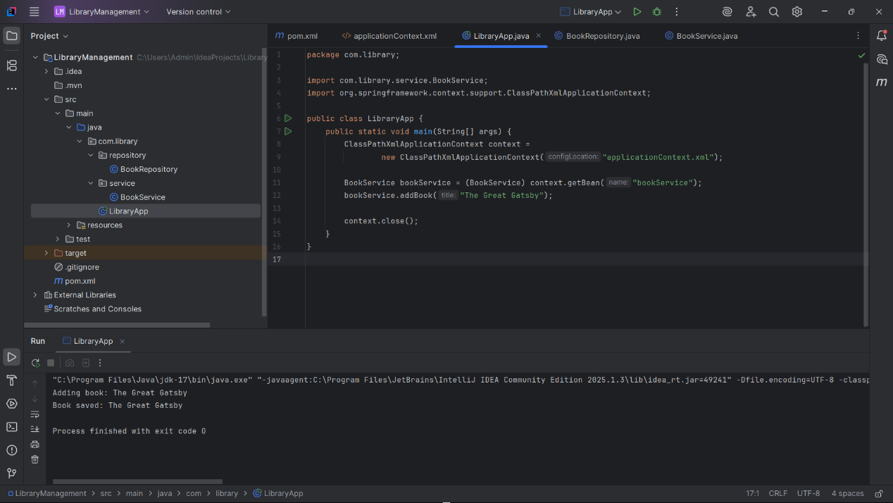

**Exercise 4: Creating and Configuring a Maven Project**

**CODE:**

**Pom.xml**

<project xmlns="http://maven.apache.org/POM/4.0.0"  
 xmlns:xsi="http://www.w3.org/2001/XMLSchema-instance"  
 xsi:schemaLocation="http://maven.apache.org/POM/4.0.0  
 http://maven.apache.org/xsd/maven-4.0.0.xsd">  
  
 <modelVersion>4.0.0</modelVersion>  
  
 <groupId>com.library</groupId>  
 <artifactId>LibraryManagement</artifactId>  
 <version>1.0-SNAPSHOT</version>  
  
 <dependencies>  
  
 <dependency>  
 <groupId>org.springframework</groupId>  
 <artifactId>spring-context</artifactId>  
 <version>5.3.34</version>  
 </dependency>  
  
  
 <dependency>  
 <groupId>org.springframework</groupId>  
 <artifactId>spring-aop</artifactId>  
 <version>5.3.34</version>  
 </dependency>  
  
  
 <dependency>  
 <groupId>org.springframework</groupId>  
 <artifactId>spring-webmvc</artifactId>  
 <version>5.3.34</version>  
 </dependency>  
  
 <dependency>  
 <groupId>org.slf4j</groupId>  
 <artifactId>slf4j-api</artifactId>  
 <version>1.7.36</version>  
 </dependency>  
 </dependencies>  
  
 <build>  
 <plugins>  
 <plugin>  
 <groupId>org.apache.maven.plugins</groupId>  
 <artifactId>maven-compiler-plugin</artifactId>  
 <version>3.8.1</version>  
 <configuration>  
 <source>1.8</source>  
 <target>1.8</target>  
 </configuration>  
 </plugin>  
 </plugins>  
 </build>  
</project>

**OUTPUT:**

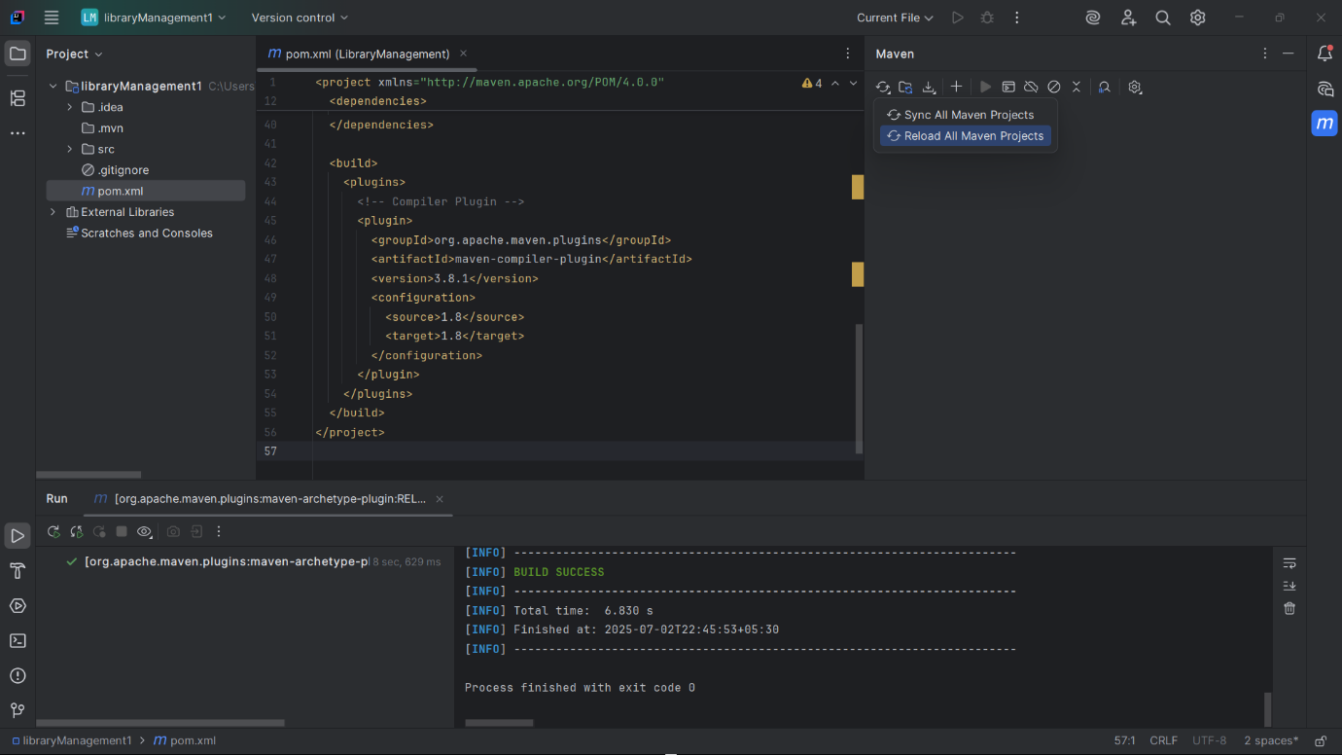

**Exercise 5: Configuring the Spring IoC Container**

**CODE:**

**Pom.xml**

<project xmlns="http://maven.apache.org/POM/4.0.0" xmlns:xsi="http://www.w3.org/2001/XMLSchema-instance"  
 xsi:schemaLocation="http://maven.apache.org/POM/4.0.0 http://maven.apache.org/xsd/maven-4.0.0.xsd">  
 <modelVersion>4.0.0</modelVersion>  
  
 <groupId>com.example.library</groupId>  
 <artifactId>library-management</artifactId>  
 <version>1.0-SNAPSHOT</version>  
 <packaging>jar</packaging>  
  
 <name>library-management</name>  
 <url>http://maven.apache.org</url>  
  
 <properties>  
 <project.build.sourceEncoding>UTF-8</project.build.sourceEncoding>  
 </properties>  
  
 <dependencies>  
 <!-- Spring Core -->  
 <dependency>  
 <groupId>org.springframework</groupId>  
 <artifactId>spring-core</artifactId>  
 <version>5.3.32</version>  
 </dependency>  
  
 <!-- Spring Context -->  
 <dependency>  
 <groupId>org.springframework</groupId>  
 <artifactId>spring-context</artifactId>  
 <version>5.3.32</version>  
 </dependency>  
 </dependencies>  
  
</project>

**MainApp.java**

package com.example.library;  
  
import org.springframework.context.ApplicationContext;  
import org.springframework.context.support.ClassPathXmlApplicationContext;  
  
import com.example.library.service.BookService;  
  
public class MainApp {  
 public static void main(String[] args) {  
 ApplicationContext context = new ClassPathXmlApplicationContext("applicationContext.xml");  
  
 BookService bookService = (BookService) context.getBean("bookService");  
 bookService.listBooks();  
 }  
}

**applicationContext.xml**

<?xml version="1.0" encoding="UTF-8"?>  
<beans xmlns="http://www.springframework.org/schema/beans"  
 xmlns:xsi="http://www.w3.org/2001/XMLSchema-instance"  
 xsi:schemaLocation="  
 http://www.springframework.org/schema/beans  
 http://www.springframework.org/schema/beans/spring-beans.xsd">  
  
   
 <bean id="bookRepository" class="com.example.library.repository.BookRepository" />  
  
  
 <bean id="bookService" class="com.example.library.service.BookService">  
 <property name="bookRepository" ref="bookRepository" />  
 </bean>  
  
</**beans>**

**BookRepository.java**

package com.example.library.repository;  
  
public class BookRepository {  
 public void displayBooks() {  
 System.*out*.println("Displaying list of books from repository.");  
 }  
}

**BookService.java**

package com.example.library.service;  
  
import com.example.library.repository.BookRepository;  
  
public class BookService {  
 private BookRepository bookRepository;  
  
 public void setBookRepository(BookRepository bookRepository) {  
 this.bookRepository = bookRepository;  
 }  
  
 public void listBooks() {  
 System.*out*.println("BookService: Fetching books...");  
 bookRepository.displayBooks();  
 }  
}

**OUTPUT:**

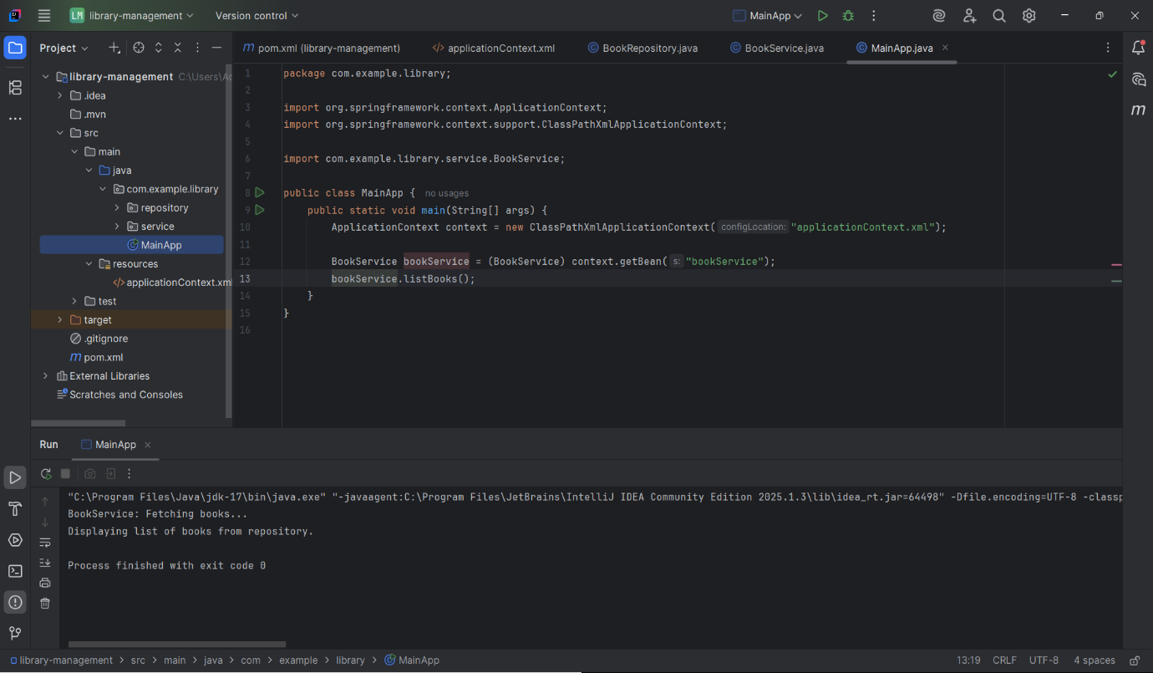

**Exercise 7: Implementing Constructor and Setter Injection**

**CODE:**

**Pom.xml**

<project xmlns="http://maven.apache.org/POM/4.0.0" xmlns:xsi="http://www.w3.org/2001/XMLSchema-instance"  
 xsi:schemaLocation="http://maven.apache.org/POM/4.0.0 http://maven.apache.org/xsd/maven-4.0.0.xsd">  
 <modelVersion>4.0.0</modelVersion>  
  
 <groupId>com.example.library</groupId>  
 <artifactId>library-management</artifactId>  
 <version>1.0-SNAPSHOT</version>  
 <packaging>jar</packaging>  
  
 <name>library-management</name>  
 <url>http://maven.apache.org</url>  
  
 <properties>  
 <project.build.sourceEncoding>UTF-8</project.build.sourceEncoding>  
 </properties>  
  
 <dependencies>  
 <!-- Spring Context (includes core) -->  
 <dependency>  
 <groupId>org.springframework</groupId>  
 <artifactId>spring-context</artifactId>  
 <version>5.3.32</version>  
 </dependency>  
 </dependencies>  
  
</project>

**BookRepository.java**

package com.example.library.repository;  
  
public class BookRepository {  
 public void displayBooks() {  
 System.*out*.println("Displaying list of books from repository.");  
 }  
}

**LibraryManagementApplication.java**

package com.example.library;  
  
import org.springframework.context.ApplicationContext;  
import org.springframework.context.support.ClassPathXmlApplicationContext;  
import com.example.library.service.BookService;  
  
public class LibraryManagementApplication {  
 public static void main(String[] args) {  
 ApplicationContext context = new ClassPathXmlApplicationContext("applicationContext.xml");  
  
 BookService bookService = (BookService) context.getBean("bookService");  
 bookService.listBooks();  
 }  
}

applicationContext.xml

<?xml version="1.0" encoding="UTF-8"?>  
<beans xmlns="http://www.springframework.org/schema/beans"  
 xmlns:xsi="http://www.w3.org/2001/XMLSchema-instance"  
 xsi:schemaLocation="  
 http://www.springframework.org/schema/beans  
 http://www.springframework.org/schema/beans/spring-beans.xsd">  
  
 <bean id="bookRepository" class="com.example.library.repository.BookRepository" />  
  
 <bean id="bookService" class="com.example.library.service.BookService">  
  
 <constructor-arg value="Library Book Service" />  
  
  
 <property name="bookRepository" ref="bookRepository" />  
 </bean>  
  
</beans>

**BookService.java**

package com.example.library.service;  
  
import com.example.library.repository.BookRepository;  
  
public class BookService {  
 private String serviceName;   
 private BookRepository bookRepository;   
  
   
 public BookService(String serviceName) {  
 this.serviceName = serviceName;  
 }  
   
 public void setBookRepository(BookRepository bookRepository) {  
 this.bookRepository = bookRepository;  
 }  
  
 public void listBooks() {  
 System.*out*.println("[" + serviceName + "] Fetching books...");  
 bookRepository.displayBooks();  
 }  
}

**

**Exercise 9: Creating a Spring Boot Application**

**CODE:**

**BookController.java**

package com.example.library.controller;  
  
import com.example.library.model.Book;  
import com.example.library.repository.BookRepository;  
import org.springframework.beans.factory.annotation.Autowired;  
import org.springframework.web.bind.annotation.*;  
  
import java.util.List;  
  
@RestController  
@RequestMapping("/api/books")  
public class BookController {  
  
 @Autowired  
 private BookRepository bookRepository;  
  
 @GetMapping  
 public List<Book> getAllBooks() {  
 return bookRepository.findAll();  
 }  
  
 @PostMapping  
 public Book createBook(@RequestBody Book book) {  
 return bookRepository.save(book);  
 }  
  
 @GetMapping("/{id}")  
 public Book getBookById(@PathVariable Long id) {  
 return bookRepository.findById(id).orElse(null);  
 }  
  
 @PutMapping("/{id}")  
 public Book updateBook(@PathVariable Long id, @RequestBody Book bookDetails) {  
 Book book = bookRepository.findById(id).orElse(null);  
 if (book != null) {  
 book.setTitle(bookDetails.getTitle());  
 book.setAuthor(bookDetails.getAuthor());  
 book.setPrice(bookDetails.getPrice());  
 return bookRepository.save(book);  
 }  
 return null;  
 }  
  
 @DeleteMapping("/{id}")  
 public void deleteBook(@PathVariable Long id) {  
 bookRepository.deleteById(id);  
 }  
}

**Book.java**

package com.example.library.model;  
  
import jakarta.persistence.Entity;  
import jakarta.persistence.GeneratedValue;  
import jakarta.persistence.GenerationType;  
import jakarta.persistence.Id;  
  
@Entity  
public class Book {  
  
 @Id  
 @GeneratedValue(strategy = GenerationType.*IDENTITY*)  
 private Long id;  
  
 private String title;  
 private String author;  
 private double price;  
  
 public Long getId() { return id; }  
 public void setId(Long id) { this.id = id; }  
  
 public String getTitle() { return title; }  
 public void setTitle(String title) { this.title = title; }  
  
 public String getAuthor() { return author; }  
 public void setAuthor(String author) { this.author = author; }  
  
 public double getPrice() { return price; }  
 public void setPrice(double price) { this.price = price; }  
}

**BookRepository.java**

package com.example.library.repository;  
  
import com.example.library.model.Book;  
import org.springframework.data.jpa.repository.JpaRepository;  
  
public interface BookRepository extends JpaRepository<Book, Long> {  
}

**LibraryManagementApplication.java**

package com.example.library;  
  
import org.springframework.boot.SpringApplication;  
import org.springframework.boot.autoconfigure.SpringBootApplication;  
  
@SpringBootApplication  
public class LibraryManagementApplication {  
  
 public static void main(String[] args) {  
 SpringApplication.*run*(LibraryManagementApplication.class, args);  
 }  
}

**Application.properties**

# H2 Console  
spring.h2.console.enabled=true  
spring.h2.console.path=/h2-console  
  
# Datasource  
spring.datasource.url=jdbc:h2:mem:librarydb  
spring.datasource.driverClassName=org.h2.Driver  
spring.datasource.username=sa  
spring.datasource.password=  
  
# JPA Hibernate DDL auto  
spring.jpa.hibernate.ddl-auto=update  
spring.jpa.show-sql=true

**OUTPUT:**

